# OpenCV and Matplotlib installation tutorial

## What is OpenCV?

OpenCV is an open-source computer vision and machine learning software library. OpenCV was built to provide a common infrastructure for computer vision applications and to accelerate the use of machine perception in the commercial products. Being a BSD-licensed product, OpenCV makes it easy for businesses to utilize and modify the code.

## Python

You must have Python installed in your system, at least Python 3.8.5. You can check in Terminal like this:

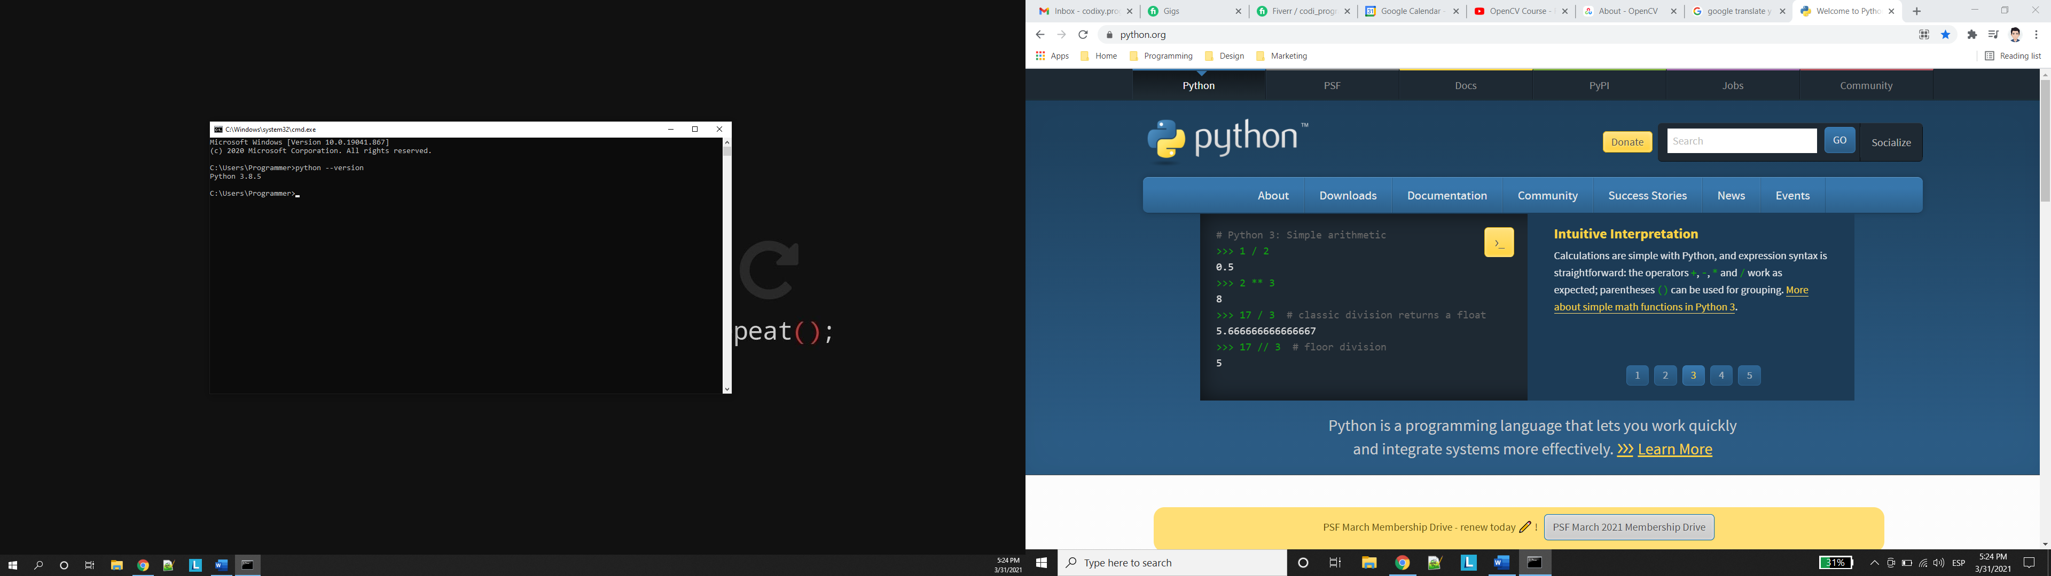

## Package requiere

### opencv-contrib-python

Include everting in the main module as well the contribution modules provided by the community. It is recommended than just install the main module.

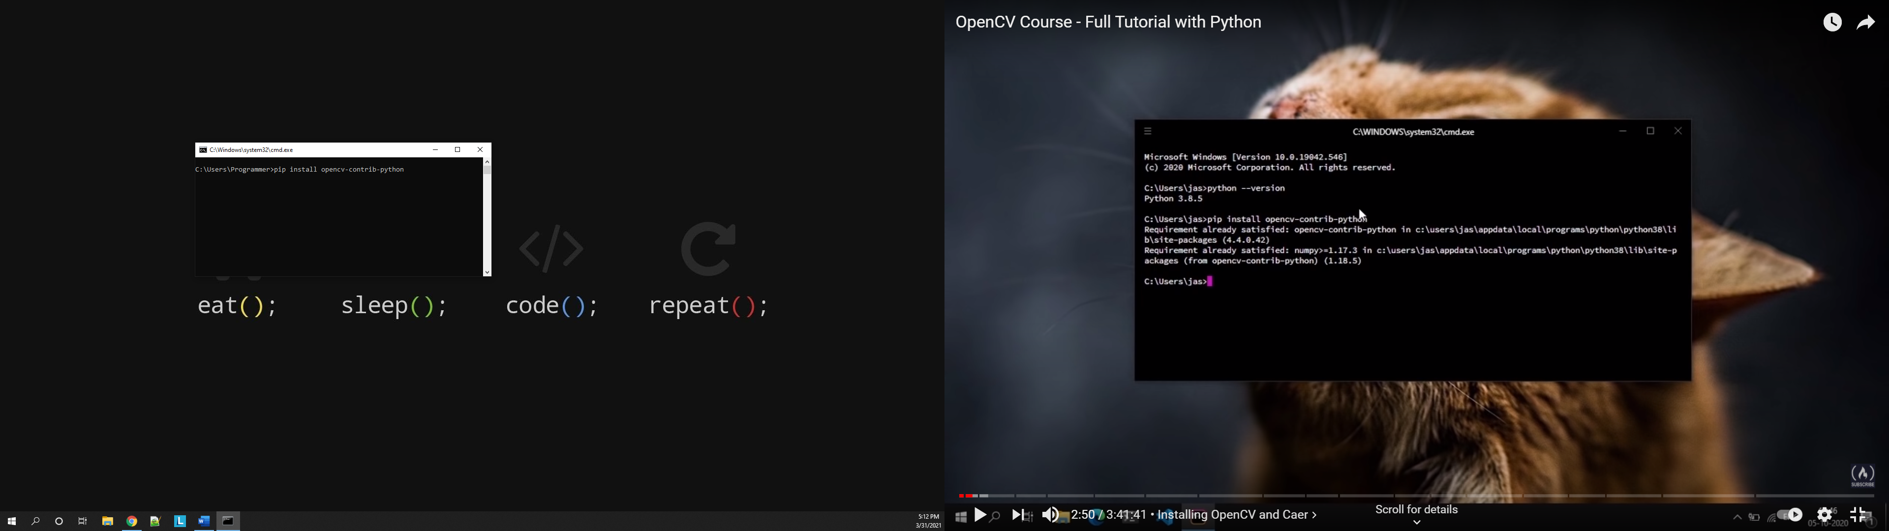

### matplotlib

Matplotlib is a comprehensive library for creating static, animated, and interactive visualizations in Python.

# Links

* <https://opencv.org/>
* <https://www.python.org/>